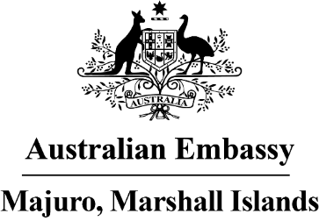

Press Release

Bringing the Torres Strait Islands to the Marshall Islands

An exhibition of twelve striking masks celebrating the rich and continuing tradition in the Torres Strait Islands opens 10 March at the NAPA building. This is the first exhibition hosted by the newly established Australian Embassy. It gives a special glimpse of the Torres Strait Islands, one of Australia’s two indigenous groups.

The official opening of the Torres Strait Islands Mask Exhibition is scheduled for Friday evening, which will be opened by Ambassador Brek Batley and Minister for Culture Jemi Nashion. The Torres Strait Islands, like the Marshall Islands, is a remote collection of islands at the very northern tip of mainland Australia, with deeply-rooted culture and traditions.

The exhibition explores the longstanding importance of masks in Torres Strait culture and ritual, and how they influence contemporary art forms. The masks represent ancestral, supernatural and totemic beings that are central to the traditional beliefs and cultural practices of Torres Strait Islanders.

Schools in Majuro and Ebeye have organized trips to visit the Exhibition. The Alele Library and students from the College of the Marshall Islands are helping elementary school students design their own masks after visiting the exhibition to learn more about the Torres Strait. High school students also have the opportunity to visit the Exhibition and learn more about the Torres Strait Islands from Embassy staff.

In Australia, the Torres Strait Regional Authority and Gab Titui Cultural Centre have partnered with the Embassy to showcase the masks and share audiovisual material from the Torres Strait as part of the Exhibition. The Embassy is grateful to the support of the Majuro Stevedore and Terminal Company Inc, which has generously provided the gallery space.

“It is a privilege to host an Exhibition featuring such an important part of Australia’s indigenous culture” said Ambassador Batley. “There are many similarities between the Marshall Islands and Torres Strait Islands, like the strong connection to land, and we hope the Mask Exhibition will build connections between two proud maritime cultures.”

Ambassador Batley is also looking forward to seeing the masks produced by the school students of Majuro and Ebeye, and hopes to send some of the student’s projects to the Gab Titui centre after the Exhibition closes. “We also plan to open this Exhibition in Ebeye in the coming months, and who knows, perhaps tour it to other atolls if they are interested.”

The exhibition is free and open to the public from 10-24 March, on weekdays from 10am to 6pm and Saturday from 12pm to 4pm. For further information or to reserve a spot for your school group, please email majuro.embassy@dfat.gov.au.

