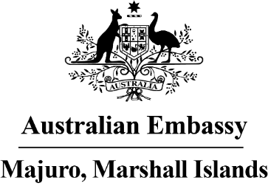

Press Release

Marshallese handicrafts on display in Australia

The talents of Marshallese weavers, artists and navigators are currently on display in Australia, with exhibitions at the Queensland Art Gallery of Modern Arts and the New South Wales Public Library.

The 10th Asia Pacific Triennial Exhibition at the Queensland Art Gallery, which opened last week and runs until April 2022, features fine arts from around the region.

Several pieces from the Marshall Islands have attracted attention. The collection includes contemporary wall art of beautifully woven Wotje flowers, and another of fish and turtle obon weavings by Elefa Handicraft (Kajnet Alfred, Erwina Philippo, and Jenny Tojar). Also on display are a jaki-ed weaving by Kathy Jetnil-Kijiner and a waa exhibit by Deaonaire Keju and a group of boys from Ebeye which creatively features canoes sculpted from soda cans.

“The woven flowers from Wotje Atoll have brought so much joy into the Gallery. Audiences are loving the bold colours and the intricacy of the weaving and learning more about the history of Wotje” said Ruth McDougall, the Curator of Pacific Art at the gallery.

A Marshallese traditional navigation stick chart is also on display at the New South Wales Public Library for the next three months. This is part of an exhibition called Maps of the Pacific 1500-1860.

Curator Maggie Patton said “While this exhibition traces the European mapping of the Pacific, the Library acknowledges that Pacific First Nations people navigated the Pacific using their shared knowledge of ocean paths, prevailing winds and rising stars for millennia."

The handicraft sector plays an important role for amimano-makers, as it provides their means of living. The Australian Embassy in Majuro has recently funded a women’s economic empowerment project to establish an RMI national handicraft development strategy to help boost revenue from local and international handicraft sales.

Ambassador Brek Batley said “We are thrilled to be helping the Marshall Islands present its stunning culture and ocean skills to the world, both through these exhibits in Australia and our own project which will help the next generation of weavers be even more successful.”

