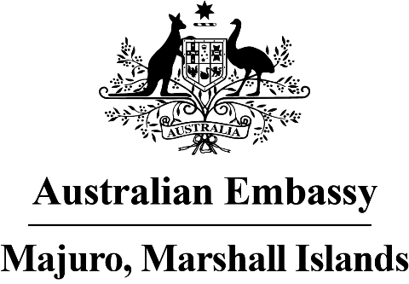
Press Release

Australian Embassy Moves into NAPA Building
16 August 2021

After several months of planning, the new Australian Embassy has opened its doors at the NAPA building. The Embassy had been temporarily based at Wallaby Downs in Long Island since April. It has now moved in to the fourth floor of the NAPA building, offering visitors sweeping views of the sea and lagoon.

The Australian Embassy celebrated the move with a morning tea with Foreign Minister Casten Nemra, Secretary Anjanette Kattil and her team. The famous Australian melt-in-your-mouth Pavlova cake, made from egg whites and slowly baked and topped with fruit, was enjoyed by guests.

Australian Ambassador Batley said “This is another special day in Australia-Marshall Islands relations. The Embassy is fully functional in its new office, and it offers a modern bright atmosphere with beautiful views.” He added “It also offers a glimpse of Australia for our visitors – they will see pictures of koalas, kangaroos, Sydney beaches, and indigenous aboriginal art.”

Foreign Minister Nemra said “Australia is a dear friend of the Marshall Islands, and the quick commencement of its embassy operations at the NAPA building is an excellent outcome. It will allow our relations to go from strength to strength.” He added “The delicious Pavolva was a diplomatic winner. We are in negotiations with the Embassy for the recipe”.

Foreign Minister Nemra generously presented Ambassador Batley with a hand-carved desk mount with the Ambassador’s name engraved and (earlier) a traditional kōrkōr canoe. The canoe has taken pride of place in the Embassy, with it having special meaning as Ambassador Batley remarked at his Credentials Ceremony with President Kabua in May that the Marshall Islands and Australia will face climate change together, highlighting “we are in the kōrkōr together as we navigate these unchartered waters with resolve, compassion, and creativity.”

Deputy Wade Carruthers arrived in Majuro in March and Ambassador Batley arrived in May. The Australian Embassy will be officially opened by Australian Foreign Minister Marise Payne in due course.

