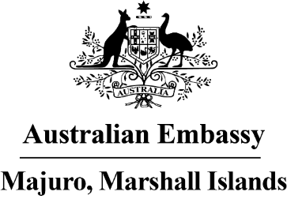

Press Release
17 October 2022

The Australia-North Pacific Connector:
The First Flight from Brisbane
“It feels so good to be connected again”. This was the sentiment at Majuro airport on Sunday evening (16 October) as the first regular flight from Brisbane arrived after COVID-19. Passengers landed with big smiles as they were greeted with warm Marshallese hospitality.

In partnership with Nauru Airlines, the Australian Government is supporting ‘the Australia-North Pacific Connector’ – a fortnightly flight route between Brisbane, Nauru, Tarawa, Majuro and Pohnpei. It will offer passenger and cargo services. The Australian Government will help financially support the route, if needed, during the initial re-establishment phase.

Ambassador Brek Batley said “Connectivity is critical in the Pacific. This is about bringing our peoples together and rejoining families. But it’s also about creating opportunities, whether in tourism, trade, or services like education. Let’s see if we can get more Australian fruit or lamb regularly on the shelves in the supermarkets? And we’ll continue to explore how this flight route might support Marshall Islands’ fish exports or the movement of workers into or out of RMI. We must work creatively together which will help regional economic growth.”

Australia’s Pacific Flights Program has supported over 450 flights in the Pacific during the COVID-19 pandemic, across 14 routes and 10 countries. This has helped to keep communities connected, maintain supply chains, and deliver critical medicines. The Program also supports key flight routes to be re-established, reducing financial risk for airlines in the initial phase.

Ambassador Batley said “We’re talking to the Office of Commerce, Investment and Tourism in Majuro on small steps that might see more Australian tourists returning to these beautiful shores. Every Australian that visits here, or every Marshallese that visits Brisbane, is one more thread weaved into our joint Jaki ed. As both of our Foreign Ministers Penny Wong and Kitlang Kabua said, strengthening people-to-people ties is so important to deepen our relationship even further.”

Nauru Airlines will run the service fortnightly, with the next flight arriving on October 30. Tickets are available through Nauru Airlines. More information on the Pacific Flights Program: https://www.dfat.gov.au/geo/pacific/partnering-with-our-pacific-family-to-build-covid19-resilience

