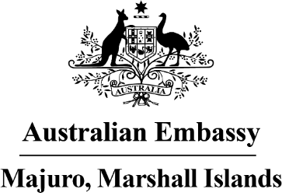

Press Release

It’s time to tuuj: The Australian Embassy invites all to join the first annual RMI Dance Power Competition with partners Power 103.5, OCIT and Sunrice
The Australian Embassy Majuro’s is proud to announce the RMI Dance Power Competition in the RMI will kick off from 5PM on Saturday 18 June at Delap Park.
The event is free and open to all those who wish to attend – we welcome everyone in RMI to head on down to Delap Park, join in the fun and tuuj the night away.
The Australian Embassy is partnering with Power 103.5 who are co-sponsoring the event to celebrate their six year anniversary and the RMI Office of Commerce, Investment and Tourism who will feed the crowd with a summer night market. The OCIT night markets have been developed as a way to help feature local businesses and entrepreneurs during the COVID-19 pandemic to showcase local products and reflect Marshallese culture, identities and ways of life. Australian company Sunrice are generously donating major cash prizes to the winners of the competition, with small vouchers and gifts from local Marshallese businesses available in the run up to the event.
Chargé d’affaires Katrina Murray said “since we opened the Embassy last year, we’ve loved all the dances that are at every event – the people of the Marshall Islands really know how to dance and have fun! So we thought we’d put together a competition to try to find the best dance group in the RMI with our very first #RMIdancepower event.”
“We’ve been so grateful to work with amazing partners like Power 103.5 who are celebrating their 6th anniversary kemem and OCIT are putting together some amazing stalls for a night market, so everyone will be well fed, and of course Australian company Sunrice for their generous sponsorship of the prizes,” she added. “And we’ve got an amazing half time show featuring indigenous dance theatre Bangarra so we can bring a taste of Australian dance to the night!”
Any dance style, from traditional Marshallese styles, to contemporary, to hip-hop to anything in between is welcome. Dance groups are encouraged to make their dances unique, eye-catching and encourage crowd reaction from the Delap park audience. The dance groups will be in with a chance to win a massive USD 1700 in cash prizes thanks to Sunrice. Four specially selected judges will be picking the best groups based on crowd engagement, choreography, staging, costumes and overall performance.
“We know its been hard to put on events in Majuro since COVID-19, so we want to put the best of Marshall Islands on the stage. We’re inviting everyone in the Marshall Islands will join us for the celebrations on Saturday night, and to cheer on the best dance talent in RMI.”
For further media enquires, please email majuro.embassy@dfat.gov.au

