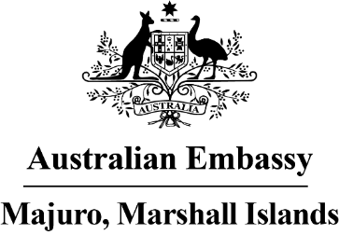

Press Release
16 August 2022

Australia’s COVID-19 support to the Marshall Islands –
helping frontliners to protect the community
Australia has been providing COVID-19 supplies over recent months to help build Marshall Islands’ pandemic preparedness, with over 3,000 tonnes of medical goods delivered in Majuro.
Australia has provided over 70,000 items covering medical supplies, protective equipment and testing kits through its Pacific-focused Essential Services and Humanitarian Corridor program and National Medical Stockpile. This includes 16,000 rapid antigen tests, 3,200 GeneXpert cartridges, 11,800 N95 masks, 11,000 face shields, 13,000 hand sanitisers, as well as crucial COVID-19 medical supplies such as pulse oximeters, stethoscopes and thermometers.
These supplies were given to the Ministry of Health and Human Services and National Disaster Management Office to help frontline workers, including the doctors, nurses, police, NDC staff, volunteers and others working around the clock to help keep us all safe.
These vital COVID-19 materials have been coordinated under Australia’s Pacific Flights Program, which has helped deliver urgent supplies and personnel across the region. In coming weeks, it will also support the transport of medical personnel to Majuro from the Pacific to reinforce the Ministry of Health.
“We are all in this together. Our support, along with that of the US, Japan, Taiwan, and NZ among others, should help protect lives”, said Ambassador Brek Batley. “We want the Government and all frontline workers to feel that they have the supplies needed to help keep communities safe. They’re doing a great job, and it’s heartening to see the community spirit in this emergency.”
These deliveries come on top of Australia’s support for the roll out of US CDC-supplied vaccines to neighbouring islands. This involved working with the Ministry of Health, Indies Trader and Air Marshall Islands to deliver first round vaccines, boosters and critical paediatric doses and medical personnel across RMI over the past 12 months. The Embassy has also worked with IOM to deliver vulnerable households with menstrual health hygiene packs which include mask supplies and funded local NGO DeafFlourish to help their COVID-19 preparedness campaigns.
This is part of Australia’s commitment to get the Pacific vaccinated, with over 60 million doses supported by Australia in the Indo-Pacific, and to bolster COVID-19 preparedness and recovery.
For further media enquiries, please email majuro.embassy@dfat.gov.au.

