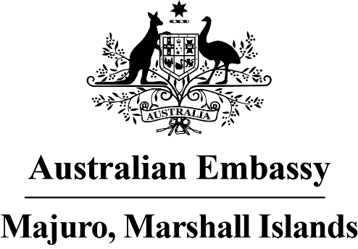

Press Release

Inaugural Australia Day celebrations

The newly established Australian Embassy has marked its inaugural Australia Day celebrations in the Marshall Islands.

On 26 January the Australian Ambassador Brek Batley hosted a large event to celebrate Australia’s national day which offered a wonderful chance for Marshallese to learn more about Australia. The celebrations, which were sponsored by Australian company Sunrice, included iconic Australian music, indigenous Australian culture, and the best of Australian fare, including lamb, kangaroo salami and delicious lamington cakes. Guests toasted Australia Day with the Embassy’s favourite Australian wines, beers and juices.

Adding to the special atmosphere, the Marshall Islands Resort was a sea of green and gold, with all guests dressed in Australia’s national sporting colours. The sounds of Australia’s famous laughing Kookaburra bird also echoed out during the night. The talents of young singer Lewa were clear for all, with her beautiful renditions of the national anthems and Australian songs like My Island Home.

Australians celebrate Australia Day by honouring over 60,000 years of indigenous history, reflecting on Australia’s modern history including sacrifices to protect Australia as an open, democratic society and celebrating Australia’s bright multicultural future.

In a recorded message on the night, Australia’s Minister for International Development and the Pacific Zed Seselja noted the importance of strong values as the corner stone of Australia’s future. Such values, including freedom, democracy, equity, diversity, and addressing climate change, are shared across the Pacific and bring all of us together. Foreign Minister Nemra also reflected on Australia and RMI’s close partnership.

Ambassador Batley said “Australia Day is about bringing all Australians together, celebrating all parts of our culture, being proud of our values, and sharing this with friends. We’re so pleased to now be able to do this every year in Majuro. Our Embassy team says kommol tata for the incredibly warm welcome we’ve received from our Marshallese friends for our first Australia Day event.”

