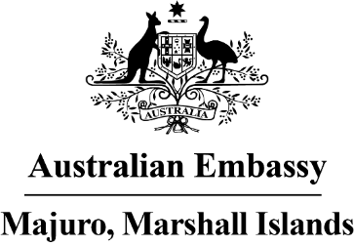

Press Release

Australia Post returns to the Marshall Islands

Australia Post has announced it is resuming services to the Republic of the Marshall Islands, following a COVID-19 hiatus.
Chargé d’affaires Katrina Murray said “how wonderful to see AusPost services start delivering again to the Marshall Islands after a COVID-19 interruption. Connectivity is really important to both countries, and the return of AusPost is a great symbol of the close linkages between the RMI and Australia.”
AusPost maiI will travel from Australia to Los Angeles and then transit via US Postal Service to RMI. Postal services will become more regular as aviation services return to pre-pandemic operations across the world.
To check the status of international postal services departing Australia, visit: https://auspost.com.au/service-updates/international-service-updates
For further media enquiries please contact: majuro.embassy@dfat.gov.au.

