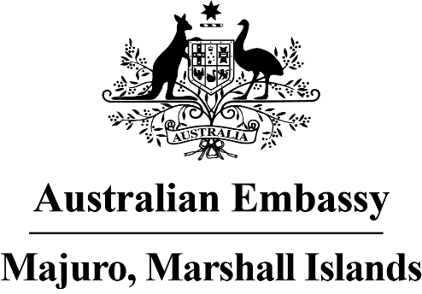

Press Release

Celebrating 34 years together

On 8 July 1987, Australia officially recognised the Marshall Islands, the third country to do so. Since then, and even before, we have enjoyed a deep friendship based on mutual trust, respect, and shared values.

Over the past 34 years, we have been there for each other, in good times and bad. We have supported each other during natural disasters, worked closely on Pacific-wide issues, and helped each other in the UN and global organisations. Our common interests, such as on rule of law, freedom, democracy and the environment, binds us together in a fast-changing world with new risks.

Australian volunteers and experts are so proud to have been part of the development journey of the Marshall Islands, including contributing to the drafting of the original constitution and the growth of organisations like WAM and WUTMI. The links between our communities will grow – we want even more Marshallese to visit, study, train and work in Australia, including on Australia Award and Defence scholarships. We are best when we learn from each other.

The opening of the new Australian Embassy this year, with Ambassador Brek Batley living in Majuro, will further deepen our trusted relationship. It builds on the Australian Defence presence here since the early 1990s, and will help shape new areas of cooperation. This includes promoting skills development, women’s empowerment, and private sector-led growth. As an example, the Embassy has advertised new grant opportunities for community organisations and on-line study opportunities for young professionals on its Facebook page.

Australians and Marshallese have so much in common. We have a shared love of sport, fishing, fun, and family. We both have truly remote communities. We also face common challenges, including drought, a changing climate, fisheries management, maritime security, and preserving cultural traditions. As integral members of the Blue Pacific family, we both look for ways to improve our region, pursue the Boe Declaration on security, and build prosperity for our people.

We look forward to the next 34 years of friendship, with more waters to be sailed together and more joint achievements.

